Display the Department id, name and its manager id and the name of its manager.

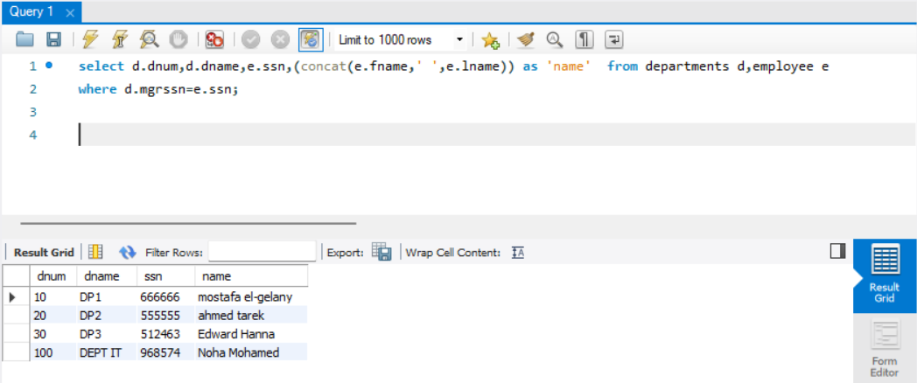

Display the departments’ name and the project name of the under their control.

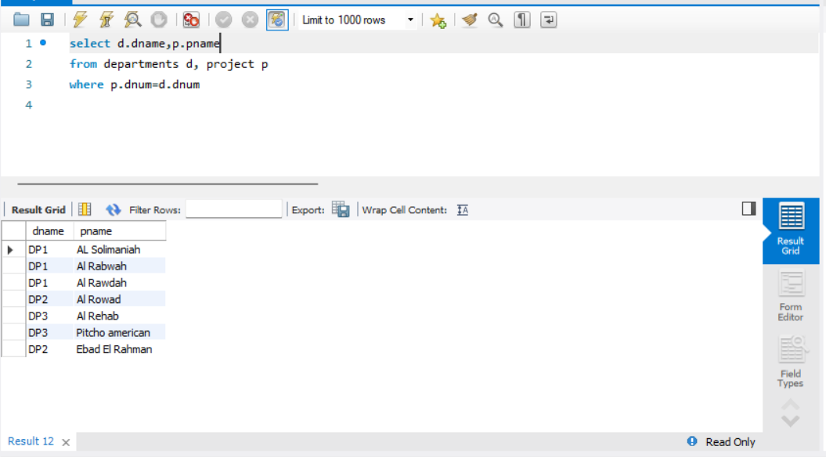

Display the dependent name for all the dependence and the name of the employee they depend on him/her.
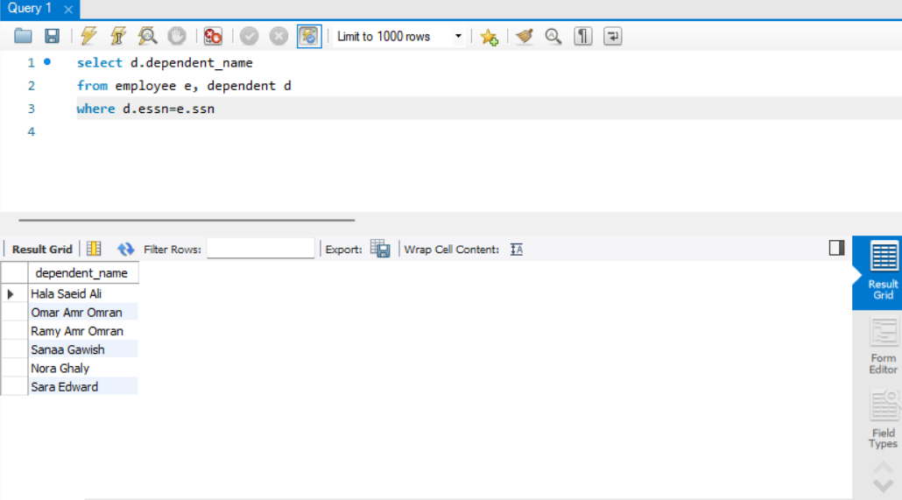

Retrieve the fname, pname of all employees work in department 10 who works more than or equal 10 hours per week on ‘AL Rabwah’ project.

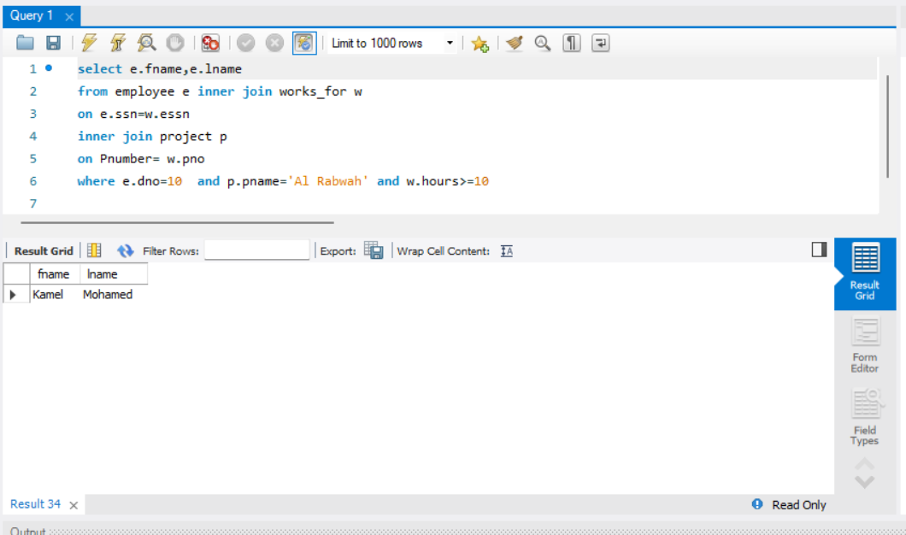

Find the fname of the employees who directly supervised with ‘Kamel Mohamed’.
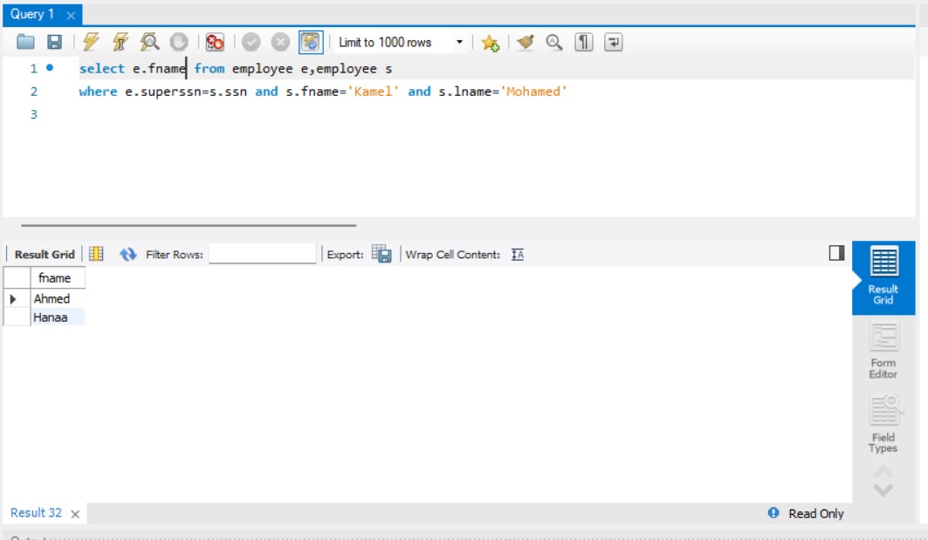

- List the last name of all managers who have no dependents.
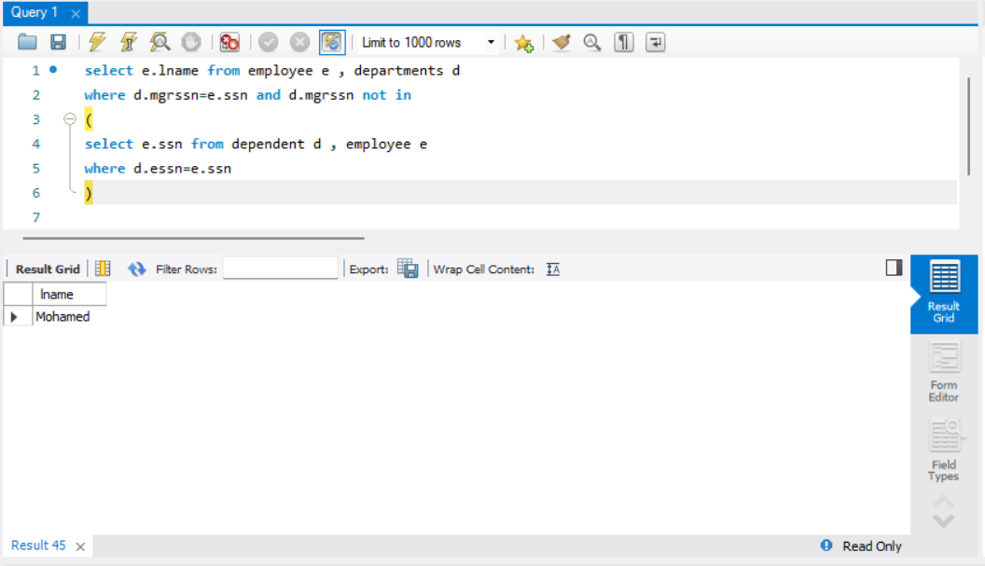

Display the department name which has the smallest employee ID over all employees' ID.

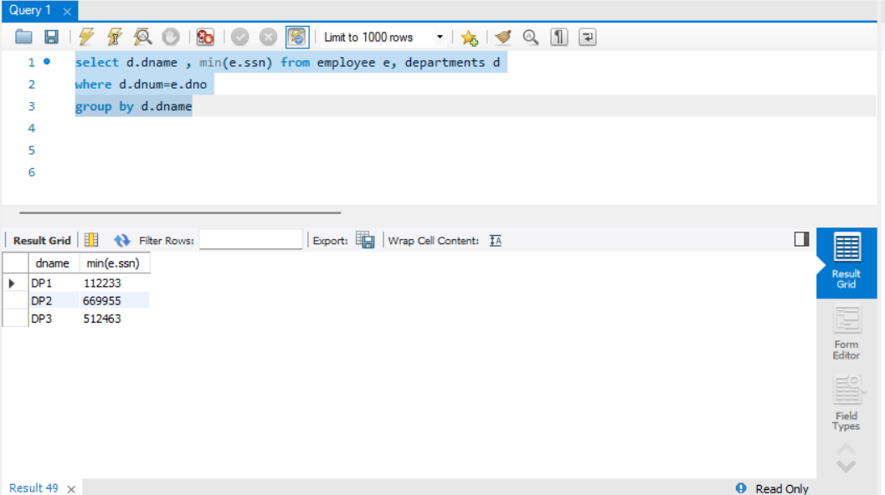

- For each department, retrieve the department name and the maximum, minimum and average salary of its employees.

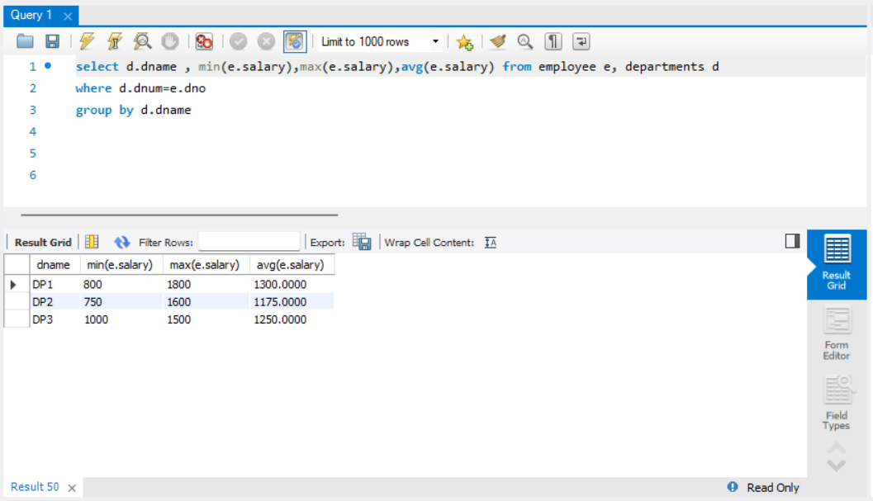

- For each department >>> display department number, department name and number of its employees
-- if its average salary is less than 1200
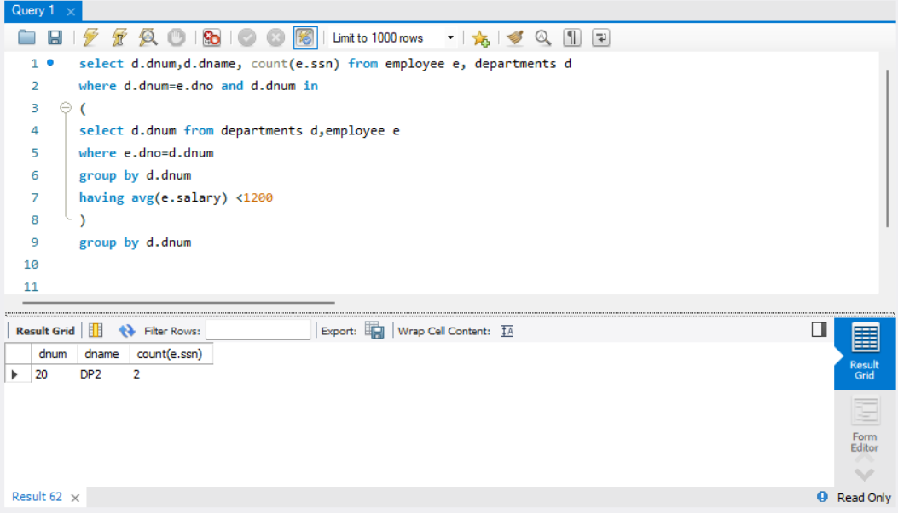

Retrieve a list of employees (fname) and the projects (project name) they are working on ordered by department no, last name, first name.
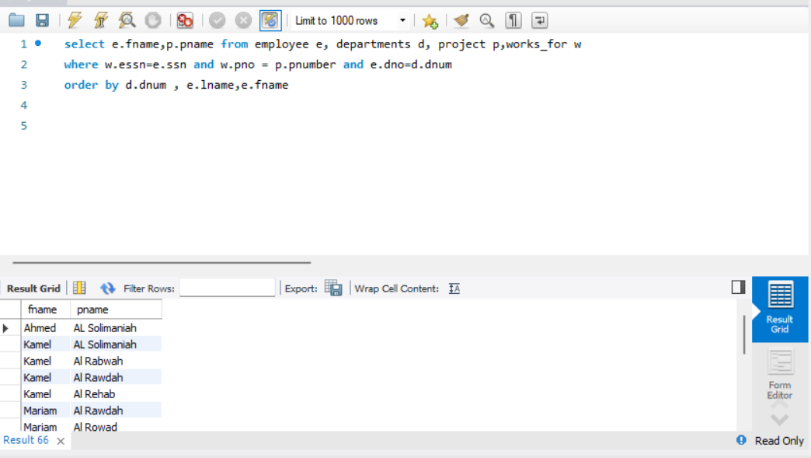

Find the project number, the controlling department name, the department manager last name, address and birthdate. For each project located in ‘Cairo’ City
